**ABSTRACT**

Emotion recognition is one of the challenging problems in machine version systems. The most expressive way humans display emotions is through facial expressions. In this project, we extend texture based facial expression recognition with a method of 2D image processing implemented for extracting of features and a neural network based decision trees. The algorithm applies a set of preprocessing and divides the image into two main parts (eyes and lips) and draws Biezer curves for main parts in order to find the emotions. Experimental results shows that the accuracy of the system is 80% through proposed method.

**CHAPTER 1**

**INTRODUCTION**

Facial expression analysis has been attracting considerable attention in the advancement of human machine interface since it provides a natural and efficient way to communicate between humans. Some application areas related to face and its expressions include personal identification and access control, videophone and teleconferencing, forensic applications, human-computer interaction, automated surveillance, cosmetology, and so on. But the performance of the face detection certainly affects the performance of all the applications. Many methods have been proposed to detect human face in images, they can be classified into four categories:

* knowledge-based methods
* feature-based methods
* Template-based methods
* Appearance-based methods.

When used separately, these methods cannot solve all the problems of face detection like pose, expression, orientation, occlusion. Hence it is better to operate with several successive or parallel methods. Most of the facial expression recognition methods reported to date are focused on recognition of six primary expression categories such as: happiness, sadness, fear, anger, disgust and grief. For a description of detailed facial expressions, the Facial Action Coding System (FACS) was designed by Ekman and Friensen in the mid 70s. In FACS, motions of the muscles of the face are divided into 44 action units and any facial expression are described by their combinations.



**Fig 1.1: Genetic Flow Diagram**

**1.1 Motivation and Problem Statement**

In the beginning, facial expression analysis was essentially a research topic for psychologists. However, recent progresses in image processing and pattern recognition have motivated significantly research works on automatic facial expression recognition. In the past, a lot of effort was dedicated to recognize facial expression in still images. For this purpose, many techniques have been applied: neural networks, Gabor wavelets and active appearance models. A very important limitation to this strategy is the fact that still images usually capture the apex of the expression, i.e., the instant at which the indicators of emotion are most marked. In their daily life, people seldom show apex of their facial expression during normal communication with their counterparts, unless for very specific cases and for very brief periods of time.

The automatic facial expression recognition system includes:

* Face Detector.
* Facial feature extractor for mouth, left and right eye.
* Facial Characteristic Point - FCP extractor.
* Facial expression recognizer.

**1.2 Objectives**

The project mainly aims to come up with a solution to the facial expression recognition problem by SubProblems dividing it into sub-problems of classifications of some specific Action Units. The projects scope includes not only the two class problems which tell about whether an Action Unit is on or off, but also the multi-class problems that will inform the user about multi occurrences of more than one Action Unit at the same time. For this, different methodologies and techniques for feature extraction , normalization, selection and classification.solutions to these problems as well as taking the computational complexity and timing issues into consideration. The project objective is to implement face recognition in an optimum way in terms of run time onto the embedded system. Various algorithms and methodologies are studied and hardware resources planning will be done to achieve the goal.This kind of face recognition embedded system can be widely used in our daily life in different sectors. We hope that human life can be greatly helped with this technology.

Some typical applications are listed as follows:-

* Business Meeting, Gathering.
* Education Teaching assistant.
* Audio-visual speech recognition(visual lip reading to enhance acoustic speech recognition).

**CHAPTER 2**

**LITERATURE SURVEY**

**Facial expression recognition based on Local Binary Patterns:**

**[Liao, s.., Fan, W., Chung, C.S., & Yeung]**

Automatic facial expression analysis is an interesting and challenging problem, and impacts important applications in many areas such as human-computer interaction and data-driven animation. Deriving an effective facial representation from original face images is a vital step for successful facial expression recognition. In this paper, we empirically evaluate facial representation based on statistical local features, Local Binary Patterns, for person-independent facial expression recognition. Different machine learning methods are systematically examined on several databases. Extensive experiments illustrate that LBP features are effective and efficient for facial expression recognition. We further formulate Boosted-LBP to extract the most discriminate LBP features, and the best recognition performance is obtained by using Support Vector Machine classifiers with Boosted-LBP features.

# Facial Expression Recognition Based on Fusion of Multiple Gabor Features

# [Liu, W., & Wrang]

# In order to accomplish subject-independent facial expression recognition task, a multiple Gabor features based facial expression recognition method is presented in this paper. Different channels of Gabor filters have different contributions on the facial expression recognition and reasonable combination of these features can improve the performance of a facial expression recognition system. NN based data fusion method is designed for facial expression recognition in this paper. Experimental results show that the facial expression recognition rate can be improved by using multiple channel features and neural network fusion.

# Recognition of facial expressions using Gabor wavelets and learning vector quantization [Bashyal & Venayagamoorthy]

# Facial expression recognition has potential applications in different aspects of day-to-day life not yet realized due to absence of effective expression recognition techniques. This paper discusses the application of Gabor filter based feature extraction in combination with learning vector quantization (LVQ) for recognition of seven different facial expressions from still pictures of the human face. The results presented here are better in several aspects from earlier work in facial expression recognition. Firstly, it is observed that LVQ based feature classification technique. Secondly, this study indicates that the Japanese Female Facial Expression (JAFFE) database contains expressers that expressed expressions incorrectly and these incorrect images adversely affect the development of a reliable facial expression recognition system. By excluding the two expressers from the data set, an improvement in recognition rate from 87.51% to 90.22% has been achieved.

# PERFORMANCE COMPARISONS OF FACIAL EXPRESSION RECOGNITION IN JAFFE DATABASE [Shih, F. Y., Chung]

# Facial expression provides an important behavioral measure for studies of emotion, cognitive processes, and social interaction. Facial expression recognition has recently become a promising research area. Its applications include human-computer interfaces, human emotion analysis, and medical care and cure. In this paper, we investigate various feature representation and expression classification schemes to recognize seven different facial expressions, such as happy, neutral, angry, disgust, sad, fear and surprise, in the JAFFE database. Experimental results show that the method of combining 2D-LDA (Linear Discriminate Analysis) and SVM (Support Vector Machine) outperforms others. The recognition rate of this method is 95.71% by using leave-one-out strategy and 94.13% by using cross-validation strategy. It takes only 0.0357 second to process one image of size 256 × 256.

# Facial Expression Recognition in JAFFE Dataset Based on Gaussian Process Classification

# The Gaussian process (GP) approaches to classification synthesize Bayesian methods and kernel techniques, which are developed for the purpose of small sample analysis. Here we propose a GP model and investigate it for the facial expression recognition in the Japanese female facial expression dataset. By the strategy of leave-one-out cross validation, the accuracy of the GP classifiers reaches 93.43% without any feature selection/extraction. Even when tested on all expressions of any particular expressor, the GP classifier trained by the other samples outperforms some frequently used classifiers significantly. In order to survey the robustness of this novel method, the random trial of 10-fold cross validations is repeated many times to provide an overview of recognition rates. The experimental results demonstrate a promising performance of this application.

# Facial expression recognition considering individual differences in facial structure and texture

# Facial expression recognition (FER) plays an important role in human-computer interaction. The recent years have witnessed an increasing trend of various approaches for the FER, but these approaches usually do not consider the effect of individual differences to the recognition result. When the face images change from neutral to a certain expression, the changing information constituted of the structural characteristics and the texture information can provide rich important clues not seen in either face image. Therefore it is believed to be of great importance for machine vision. This study proposes a novel FER algorithm by exploiting the structural characteristics and the texture information hiding in the image space. Firstly, the feature points are marked by an active appearance model. Secondly, three facial features, which are feature point distance ratio coefficient, connection angle ratio coefficient and skin deformation energy parameter, are proposed to eliminate the differences among the individuals. Finally, a radial basis function neural network is utilised as the classifier for the FER. Extensive experimental results on the Cohn-Kanade database and the Beihang University (BHU) facial expression database show the significant advantages of the proposed method over the existing ones.

# Robust facial emotion recognition using a temporal-reinforced approach

# In this paper, a temporal-reinforced approach to enhancing emotion recognition from facial images is presented. Shape and texture models of facial images are computed by using active appearance model (AAM), from which facial feature points and geometrical feature values are extracted. The extracted features are used by relevance vector machine (RVM) to recognize emotional states. We propose a temporal analysis approach to recognizing likelihood of emotional categories, such that more subtle emotion, such as degree and ratio of basic emotional states can be obtained. Furthermore, a method is developed to map the recognition result to the arousal-valence plane (A-V Plane). Experimental results verify that the performance of emotion recognition is enhanced by the proposed method.

# Facial Expression Recognition Based on SVM

An in-depth study of the multi-classification SVM is given, and the expression classification method based on SVM is proposed for the defects of the traditional classification methods. It realizes fast classification with a relatively small sub-classifier combination, reducing the classification error. Experiments show that the multi-classification method based on SVM can obviously reduce the training and testing time and improve the classification performance.

# Real-Time Mobile Facial Expression Recognition System -- A Case Study

# This paper presents a mobile application for real time facial expression recognition running on a smart phone with a camera. The proposed system uses a set of Support Vector Machines (SVMs) for classifying 6 basic emotions and neutral expression along with checking mouth status. The facial expression features for emotion recognition are extracted by Active Shape Model (ASM) fitting landmarks on a face and then dynamic features are generated by the displacement between neutral and expression features. We show experimental results with 86% of accuracy with 10 folds cross validation in 309 video samples of the extended Cohn-Kanade (CK+) dataset. Using the same SVM models, the mobile app is running on Samsung Galaxy S3 with 2.4 fps. The accuracy of real-time mobile emotion recognition is about 72% for 6 posed basic emotions and neutral expression by 7 subjects who are not professional actors.

# A Literature review on Facial Expression Recognition Techniques

# [Ms.Aswathy.R]

# Automatic facial expression recognition has become a progressive research area since it plays a major role in human-computer-interaction. The facial expression recognition finds major application in areas like social interaction and social intelligence. A review of various techniques used in facial expression recognition like principal component analysis (PCA), linear discriminate analysis (LDA) etc is done in this paper. The survey is represented in tabular form for quick reference.

# Development of a Facial Emotion Recognition Method Based on Combining AAM with DBN

# [Kwang-Eun Ko]

# In this paper, novel methods for facial emotion recognition in facial image sequences are presented. Our facial emotional feature detection and extracting based on Active Appearance Models (AAM) with Ekman’s Facial Action Coding System (FACS). Our approach to facial emotion recognition lies in the dynamic and probabilistic framework based on Dynamic Bayesian Network (DBN) with Kalman Filter for modelling and understanding the temporal phases of facial expressions in image sequences. By combining AAM and DBN, the proposed method can achieve a higher recognition performance level compare with other facial expression recognition methods. The result on the BioID dataset show a recognition accuracy of more than 90% for facial emotion reasoning using the proposed method.

# Facial expression recognition using DCT features and neural network based decision tree

# [Arun Bhadu]

# Automatic analysis of human facial expression is one of the challenging problems in machine vision systems. The most expressive way humans display emotion is through facial expression. In this paper, we extend texture based facial expression recognition, with a method of 2D image processing implemented for extraction of features and a new neural network based decision trees. The algorithm applies a set of preprocessing and divides the image into two main parts (eyes and lips apart), and implements Discrete Cosine Transform (DCT) on each part to reduce image data size in different parts of the face. Different decision tree models have been tried in order to find the best recognition rate. Experimental results show that, such a combination of decision tree with neural network to identify different facial expressions improves the recognition rate significantly.

**CHAPTER 3**

**PROPOSED WORK**

**3.1 Problem Statement**

There is an inaccurate location and tracking of facial points. Also Pose, movement and rotation of the test person are limited. Glasses may hinder classification, especially thick and dark frames in detecting emotions. Face Reader can analyze one face at a time. Face Reader cannot classify facial expressions in test persons with a partial facial paralysis.

**3.1.1 Contrast Stretching**

Contrast stretching (often called normalization) is a simple image enhancement technique that attempts to improve the contrast in an image by ‘stretching’ the range of intensity values it contains to span a desired range of values, e.g. the full range of pixel values that the image type concerned allows. It differs from the more sophisticated histogram equalization in that it can only apply a linear scaling function to the image pixel values. As a result the ‘enhancement’ is less harsh. (Most implementations accept a gray level image as input and produce another gray level image as output.)



Fig 3.1: Contrast Stretching

Contrast stretching: do min max contrast stretching of the image. Find the minimum and maximum values of the pixels in an image, and then convert pixels from the source to destination like ((pixel-min)/ (max-min))*255

**3.1.2 Skin Color Conversion**

Skin-color Conversion technique is considered as an effective tool for face detection because it is invariant to changes in size, orientation and occlusion . In this paper, we propose to use the YCbCr color space for two reasons:

* By using YCbCr color space, we can eliminate as much as possible the variation of luminance component caused by the lighting condition.
* The YCbCr domain is extensively used in digital video coding applications. YCbCr is a color space that separates the luminance from the color information. Luminance is encoded in the Y and the blueness in Cb and the redness in Cr. It is very easy too convert from RGB to YCbCr :

Analysis of YCrCb color space on human skin color.

Any RGB digital image can be converted into YCrCB color space using following equation:

Y=0.299R + 0.587G + 0.114B

Cb = -0.169R - 0.331G + 0.500B

Cr = 0.500R - 0.419G - 0.081B



Fig 3.2 skin color conversion

**3.1.3 Connected Component Labeling**

Connected-component labeling (alternatively connected-component analysis, blob extraction, region labeling, blob discovery, or region extraction) is an algorithmic application of graph theory, where subsets of connected components are uniquely labeled based on a given heuristic. Connected-component labeling is not to be confused with segmentation.

Connected-component labeling is used in computer vision to detect connected regions in binary digital images, although color images and data with higher dimensionality can also be processed. When integrated into an image recognition system or human-computer interaction interface, connected component labeling can operate on a variety of information.

**Graphical example of two-pass algorithm**:

1. The array from which connected regions are to be extracted is given below (8-connectivity based).



2.After the first pass, the following labels are generated. A total of 7 labels are generated in accordance with the conditions highlighted above.

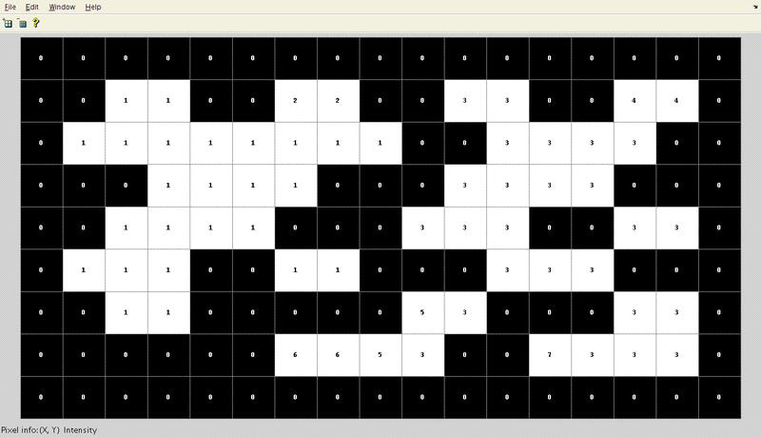

3. .Array generated after the merging of labels is carried out. Here, the label value that was the

smallest for a given region ”floods” throughout the connected region and gives two distinct labels, and hence two distinct labels.



1. Final result in color to clearly see two different regions that have been found in the array



**3.1.4 Binary Conversion of the Image**

A binary image is a digital image that has only two possible values for each pixel. Typically the two colors used for a binary image are black and white though any two colors can be used. The color used for the object(s) in the image is the foreground color while the rest of the image is the background color.



Fig 3.3 binary image

**3.1.5 Eye and Mouth Extraction Procedure**



An eye extraction procedure:

(a) A morphology-based edge image.

(b) Initial rectangular blocks to confine the eyes.

(c) Final landmark points for eye contours.

(d) Extracted eye contours.

**Mouth Extraction:**



A mouth extraction procedure.

(a) A morphology-based edge image.

(b) Initial rectangular block to confine the mouth.

(c) Final landmark points for mouth contours.

(d)Extracted mouth contours.

**3.1.6 Detecting Bezier Curves**

A Bezier curve is a parametric curve frequently used in computer graphics and related fields. Bezier curves are also used in the time domain, particularly in animation and interface design.

The recursive formula which are used to decide coordinate locations is obtained by:

BEZk,L(t) = (1−t)·BEZk,L−1(t) +t ·BEZk,L−1 +t ·BEZk−1,L−1(t)

where BEZk,k(t) = t k and BEZ0,k(t) = (1−t) k .

The coordinates of individual Bezier curve are represented by the following pair of parametric equations: x(t) = ∑ L k=0 xkBEZk,L(t)

y(t) = ∑ L k=0 ykBEZk,L(t)



Figure 3.4: Bezier curves with their control points.



Figure 3.5: Face Data(Normal and Happy)



**3.1.7 Facial Emotion with Hausdorff Distance**

In training database, there are two tables which are storing for personal information and indexes of four emotions with his/her own curves of facial expression analysis. For detection of facial emotion, we need to compute the distance a one-to-one correspondence of each interest regions between an input image and the images in the database. The Bezier curves are drawn over principal lines of facial features. To estimate a similarity matching, we first normalize the displacements that convert each width of the Bezier curve to 100 and height according to its width. We then apply the Hausdorff distance to compare the shape metric between them.

The distance dH(p,q) between two curves p(s),s ∈ [a,b] and q(t),t ∈ [c,d] is given in Equation

dH(p,q) = max{ max s∈[a,b] min t∈[c,d] |p(s)−q(t)|, max t∈[c,d] min s∈[a,b] |p(s)−q(t)|}

**CHAPTER 4**

**PROJECT DESIGN**

**4.1 System Architecture**



**4.2. UML DESIGN**

The Unified Modeling Language is a general purpose visual modeling language that is used to specify, visualize, construct, and document the artifacts of a software system. It captures decisions and understanding about systems that must be constructed. It is used to understand, design, browse, configure, maintain, and control information about such systems. The Unified Modeling Language is very important parts of developing object oriented software and the software development process. The Unified Modeling Language uses mostly graphical notations to express the design of software projects. Using the Unified Modelling Language helps project teams communicate, explore potential designs, and validate the architectural design of the software. The primary goals in the design of the Unified Modelling Language are:

• Provide users with a ready-to-use, expressive visual modelling language so they can develop and exchange meaningful models.

• Provide extensibility and specialization mechanisms to extend the core concepts.

• Be independent of particular programming languages and development processes.

• Provide a formal basis for understanding the modelling language.

• Encourage the growth of the object oriented tools market.

• Support higher-level development concepts such as collaborations, frameworks, patterns and components.

Each Unified Modelling Language diagram is designed to let developers and customers view a software system from a different perspective and in varying degrees of abstraction. UML diagrams commonly created in visual modelling tools include.

1. Use Case Diagram

2. Class Diagram

3. Sequence Diagram

4. Collaboration Diagram

5. State chart Diagram

**4.2.1. Use Case Diagram**

A use case illustrates a unit of functionality provided by the system. The main purpose of the use-case diagram is to help development teams visualize the functional requirements of a system, including the relationship of "actors” to essential processes, as well as the relationships among different use cases. A use-case diagram is typically used to communicate the high-level functions of the system and the system's scope. This Use case diagram represents the overall process of the dissertation.



Fig 4.1 **Use Case Diagram**

**4.2.2. Sequence Diagram**

Sequence diagrams show a detailed flow for a specific use case or even just part of a specific use case. They are almost self-explanatory; they show the calls between the different objects in their sequence and can show, at a detailed level, different calls to different objects. A sequence diagram has two dimensions: The vertical dimension shows the sequence of messages in the time order that they occur; the horizontal dimension shows the object instances to which the messages are sent.

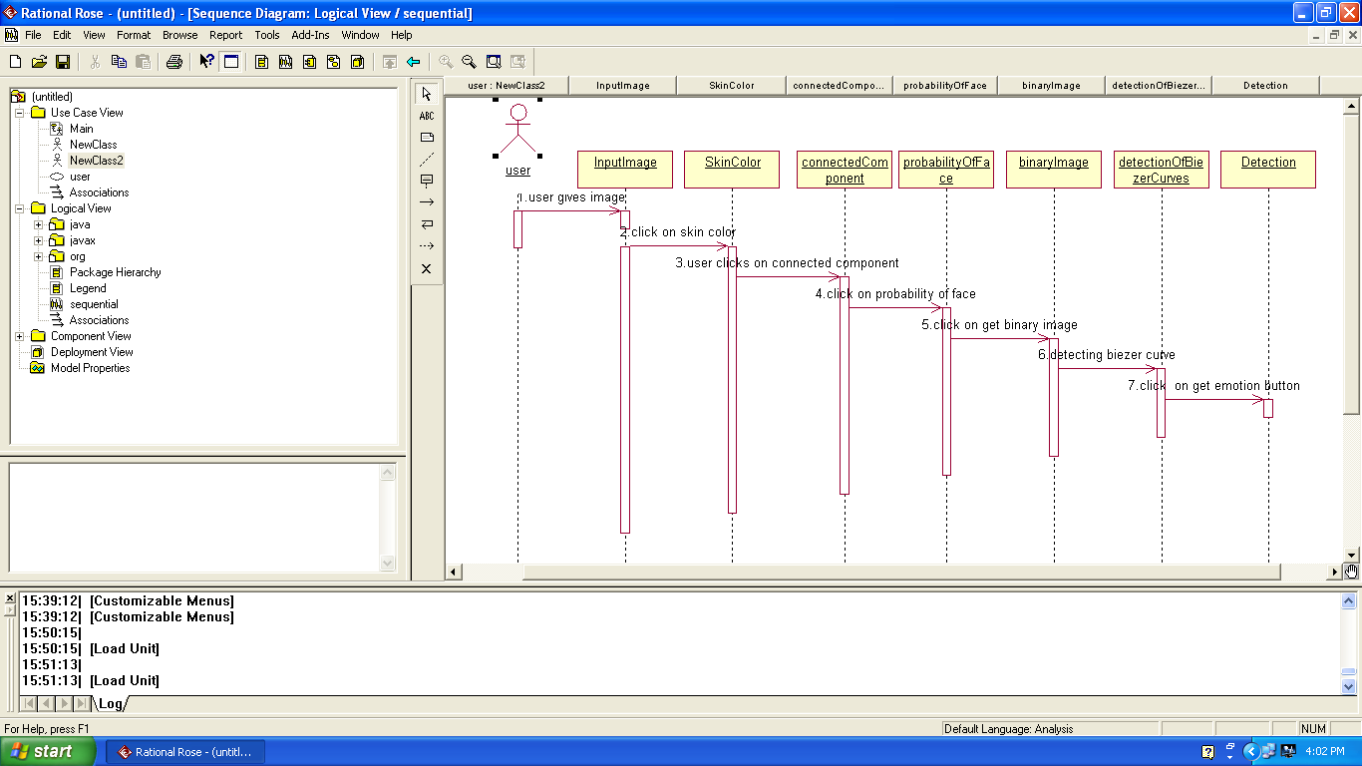

Fig 4.2 **Sequence Diagram**

**4.2.3. Class Diagram**

The class diagram shows how the different entities (people, things, and data) relate to each other; in other words, it shows the static structures of the system. A class diagram can be used to display logical classes, which are typically the kinds of things the business people in an organization. This diagram shows the overall dissertation.



**Fig 4.3 Class diagram**

**Collaboration diagram**

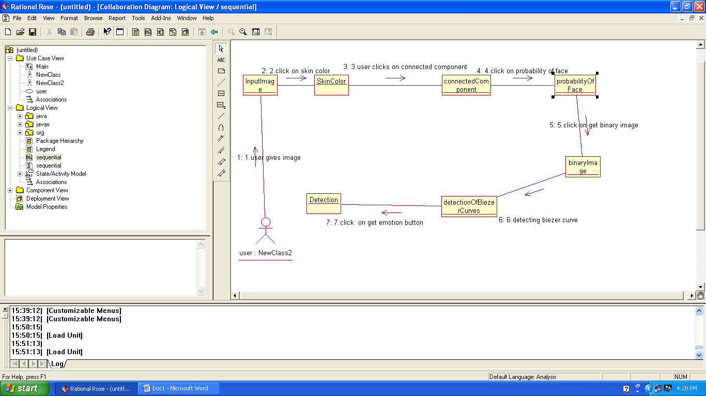 fig 4.4 collaboration diagram

**4.2.6. State Chart Diagram:**

State chart diagrams model the dynamic behaviour of individual classes or any other kind of object. They show the sequences of states that an object goes through the events that cause a transition from one state to another and the actions that result from a state change. State chart diagrams are closely related to activity diagrams. The main difference between the two diagrams is state chart diagrams are state centric, while activity diagrams are activity centric. A state chart diagrams are activity centric. A state chart diagram is typically used to model the discrete stages of an object’s lifetime, whereas an activity diagram is better suited to model the sequence of activities in a process. Each state represents a named condition during the life of an object during which it satisfies some conditions or waits for an event. State chart diagram typically contains one start state and end states. Transition connect the various states the diagram.

The following tools are used on the state chart diagram toolbox to model state chart diagrams:

• **Decisions**: A decision represents a specific location on state chart diagram where the work flow may branch based upon guard conditions.

• **Synchronization**: Synchronizations visually define forks and joins representing parallel work flow.

• **Forks and Joins**: A fork construct is used to model a single flow of control that divides into two or more separate, but simultaneous flows. A join consists of two of more flows of control that unite into single flows of control that unite into single flow of control.

• **States:** A state represents a condition or situation during the life of an object during which it satisfies some conditions or waits for some event.

• **Transitions**: A state transition indicates that an object in the source state will perform certain specified actions and enter the destination state when a specified event occurs or when certain conditions are satisfied.

• **Start states**: A start state (also called an “initial state”) explicitly shows the beginning of a work flow.

• **End States**: An end state represents a final state or terminal state.

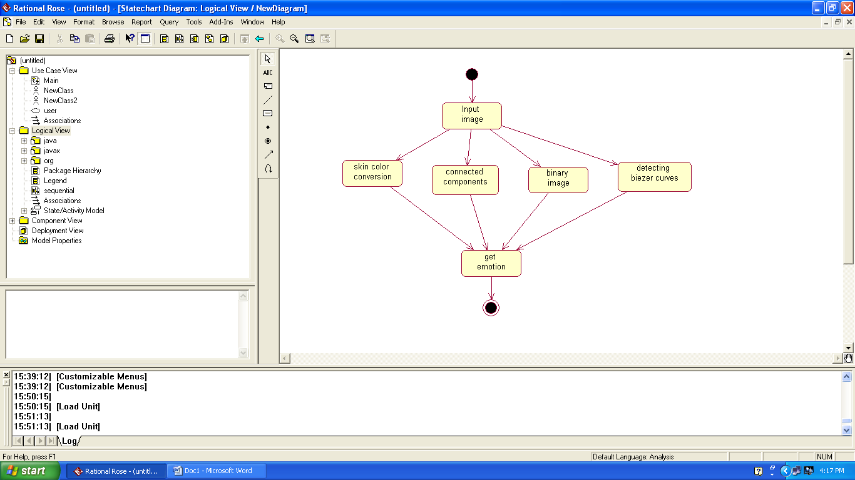

**Fig 4.5 State chart diagram**

**4.3 Requirements**

**Hardware Resources:**

* System Processor: Pentium IV or later.
* Bus: 32- Bit.
* RAM: 512MB DDR RAM.
* Hard drive: 20GB.
* Display: SVGA Color.
* Key board: Windows compatible

**Software Resources:**

* IDE: Microsoft Visual Studio 2008 and above
* Operating System: Windows 7/8/8.1/10
* .NET Framework 4.0 and above

**CHAPTER 5**

**IMPLEMENTATION & TECHNOLOGIES USED**

**5.1 Implementation**

Let’s look at the major steps associated with implementation. Note that many of these activities need to be completed ahead of time. You cannot start planning for implementation while you are actually implementing.

**Step 1: Input Image**

The image is taken captured by the web-cam or provided as input through browse

Code:

private void button1_Click(object sender, EventArgs e)

{

if (openFileDialog1.ShowDialog() == DialogResult.OK)

{

pictureBox1.Image = Image.FromFile(file_name);

contrast_function();

button_connected.Enabled = true;

button_skincolor.Enabled = true;

button2.Enabled = true;

}

}

**Step 2: Contrast Stretching Of the Image:**

It performs min max contrast stretching of the image. Find the minimum and maximum values of the pixels in an image, and then convert pixels from the source to destination like

((pixel-min) / (max-min))*255

**Code**:

private void contrast_function()

{

double nContrast = 30;

double pixel = 0, contrast = (100.0 + nContrast) / 100.0;

contrast *= contrast;

int red, green, blue;

Bitmap b = new Bitmap(pictureBox1.Image);

// GDI+ still lies to us - the return format is BGR, NOT RGB.

BitmapData bmData = b.LockBits(new Rectangle(0, 0, b.Width, b.Height), ImageLockMode.ReadWrite, PixelFormat.Format24bppRgb);

int stride = bmData.Stride;

System.IntPtr Scan0 = bmData.Scan0;

unsafe

{

byte* p = (byte*)(void*)Scan0;

int nOffset = stride - b.Width * 3;

for (int y = 0; y < b.Height; ++y)

{

for (int x = 0; x < b.Width; ++x)

{

blue = p[0];

green = p[1];

red = p[2];

pixel = red / 255.0;

pixel -= 0.5;

pixel *= contrast;

pixel += 0.5;

pixel *= 255;

if (pixel < 0) pixel = 0;

if (pixel > 255) pixel = 255;

p[2] = (byte)pixel;

pixel = green / 255.0;

pixel -= 0.5;

pixel *= contrast;

pixel += 0.5;

pixel *= 255;

if (pixel < 0) pixel = 0;

if (pixel > 255) pixel = 255;

p[1] = (byte)pixel;

pixel = blue / 255.0;

pixel -= 0.5;

pixel *= contrast;

pixel += 0.5;

pixel *= 255;

if (pixel < 0) pixel = 0;

if (pixel > 255) pixel = 255;

p[0] = (byte)pixel;

p += 3;

}

p += nOffset;

}

}

b.UnlockBits(bmData);

pictureBox1.Image = (Image)b;

**Step 3: Skin Color Conversion Of The Image:**

In skin color conversion, the skin of the person is converted to white pixel and the rest of the parts are converted to black pixel.

Any RGB digital image can be converted into YCrCB color space using following equation:

Y=0.299R + 0.587G + 0.114B

Cb = -0.169R - 0.331G + 0.500B

Cr = 0.500R - 0.419G - 0.081B

Code:

int cr_start = 140, cr_end = 170, cb_start = 105, cb_end = 150;

private void YCbCr_Click(object sender, EventArgs e)

{

double c = 0, cb = 0, cr = 255;

Bitmap bb = (Bitmap)pictureBox1.Image.Clone();

Bitmap bb1 = new Bitmap(pictureBox1.Image.Size.Width, pictureBox1.Image.Size.Height);

//Bitmap bb1 = new Bitmap(pictureBox2.Image);

int min_x = bb.Width + 5;

int max_x = 0;

int max_y = 0;

int min_y = bb.Height + 5;

/*

cr_start = Convert.ToInt16(numericUpDown_cr_start.Value);

cr_end = Convert.ToInt16(numericUpDown_cr_end.Value);

cb_start = Convert.ToInt16(numericUpDown_cb_start.Value);

cb_end = Convert.ToInt16(numericUpDown_cb_end.Value);

*/

cr_start = 140;

cr_end = 170;

cb_start = 105;

cb_end = 150;

for (int i = 1; i < bb.Width - 1; i++)

for (int j = 1; j < bb.Height - 1; j++)

{

c = 0.257 * Convert.ToDouble(bb.GetPixel(i, j).R) + 0.504 * bb.GetPixel(i, j).G + 0.098 * bb.GetPixel(i, j).B + 16;

cb = 0.148 * Convert.ToDouble(bb.GetPixel(i, j).R) - 0.291 * Convert.ToDouble(bb.GetPixel(i, j).G) + 0.439 * Convert.ToDouble(bb.GetPixel(i, j).B) + 128;

cr = 0.439 * Convert.ToDouble(bb.GetPixel(i, j).R) - 0.368 * Convert.ToDouble(bb.GetPixel(i, j).G) - 0.071 * Convert.ToDouble(bb.GetPixel(i, j).B) + 128;

//if ((cr > 140 && cr < 160) && (cb > 105 && cb < 140))actual according to papper

if ((cr > cr_start && cr < cr_end) && (cb > cb_start && cb < cb_end))//nice result for good image

{

#region finding face rectangle

/*

* finding the minimum co-ordinate and maximum co-ordinate xy

* of the image between the Cb and Cr threshold value region

*/

if (i < bb.Width / 2 && i < min_x)

{

min_x = i;

}

if ((i >= bb.Width / 2 && i < bb.Width) && i > max_x)

{

max_x = i;

}

if (j < bb.Height / 2 && j < min_y)

{

min_y = j;

}

if ((j >= bb.Height / 2 && i < bb.Height) && j > max_y)

{

max_y = j;

}

#endregion

//bb1.SetPixel(i, j, Color.FromArgb(bb.GetPixel(i, j).R, bb.GetPixel(i, j).G, bb.GetPixel(i, j).B));

bb1.SetPixel(i, j, Color.Black);

}

else bb1.SetPixel(i, j, Color.White);

}

/*

#region drawing rectangle found above

for (int i = min_x; i <= max_x; i++)

{

bb1.SetPixel(i, min_y, Color.Red);

bb1.SetPixel(i, max_y, Color.Red);

}

for (int i = min_y; i <= max_y; i++)

{

bb1.SetPixel(min_x, i, Color.Red);

bb1.SetPixel(max_x, i, Color.Red);

}

#endregion

*/

pictureBox2.Image = (Bitmap)bb1;

MessageBox.Show("Finished....");

**Step 4: Detecting Connected Region:**

Connected-component labeling is used in computer vision to detect connected regions in binary digital images, although color images and data with higher dimensionality can also be processed. When integrated into an image recognition system or human-computer.

Code:

private void connected_area()

{

Bit = (Bitmap)pictureBox2.Image.Clone();

int capacity = Bit.Height * Bit.Width;

queue_i = new Queue<int>(capacity);

queue_j = new Queue<int>(capacity);

countt = new int[capacity];

visited = new bool[Bit.Width + 5][];

#region initialization of visited boolean array

for (int i = 0; i < Bit.Width + 5; i++)

{

visited[i] = new bool[Bit.Height + 5];

for (int j = 0; j < Bit.Height + 5; j++)

visited[i][j] = false;

}

#endregion

big = new int[Bit.Width + 5][];

#region initialization of count region array

for (int i = 0; i < Bit.Width + 5; i++)

{

big[i] = new int[Bit.Height + 5];

for (int j = 0; j < Bit.Height + 5; j++)

big[i][j] = 0;

}

#endregion

int max = 0, max_bit = 0;

count_region = 1;

for (int i = 0; i < Bit.Width; i++)

{

for (int j = 0; j < Bit.Height; j++)

{

if (!visited[i][j] && (Bit.GetPixel(i, j).R == 0 && Bit.GetPixel(i, j).G == 0 && Bit.GetPixel(i, j).B == 0))

{

countt[count_region] = 0;

//MessageBox.Show(i+" "+j+" ");

BFS(i, j);

if (max < countt[count_region])

{

max = countt[count_region];

max_bit = count_region;

//MessageBox.Show(max+" ");

}

count_region++;}}}

**Step 5: Binary Conversion of The Image:**

A binary image is a digital image that has only two possible values for each pixel. Typically the two colors used for a binary image are black and white though any two colors can be used. The color used for the object(s) in the image is the foreground color while the rest of the image is the background color.

Code:

Public static byte[] imageToBinary(String imagepath)

{

FileStream fs= new FileStream(imagePath,Filemode.open,FileAccess.read);

Byte[] b= new byte[fs.length];

Fs.read(b,0,(int)fs.length);

Fs.close();

Return b;

}

**Step 6: Extracting Eyes And Lips From The Binary Image To Detect Bezier Curves:**

Left eye, right eye and the lips are extracted from the binary image and extracted from the image and Bezier curves are drawn accordingly. From the Bezier curves, emotions are detected by comparing its value from the database.

Code:

void Bezier2D(int cpts)

{

//// int npts = (b.Length) / 2;

int npts = (bLength) / 2;

int icount, jcount;

double step, t;

// Calculate points on curve

icount = 0;

t = 0;

step = (double)1.0 / (cpts - 1);

for (int i1 = 0; i1 != cpts; i1++)

{

if ((1.0 - t) < 5e-6)

t = 1.0;

jcount = 0;

p1[icount] = 0.0;

p1[icount + 1] = 0.0;

for (int i = 0; i != npts; i++)

{

double basis = Bernstein(npts - 1, i, t);

p1[icount] += basis * b1[jcount];

p1[icount + 1] += basis * b1[jcount + 1];

jcount = jcount + 2;

}

icount += 2;

t += step;

}

private void lips_bezier_draw()

{

Bitmap b = new Bitmap((Image)pictureBox1.Image.Clone());

Bitmap ba = new Bitmap(skin_color(b));

pictureBox1.Image = (Image)ba;

b = new Bitmap(pictureBox1.Image);

ba = new Bitmap(big_conect(b));

pictureBox1.Image = (Image)ba;

b = new Bitmap(pictureBox1.Image);

ba = new Bitmap(bezier(b));

pictureBox1.Image = (Image)ba;

/*

Bitmap b = new Bitmap((Bitmap)pictureBox_lips.Image.Clone());

Bitmap ba = new Bitmap(bezier(b));

pictureBox_lips_bezier.Image = (Image)ba;*/

}

**Step 7: To Detect Emotions Of The Person:**

Bezier curves are drawn and respected values from the Bezier curves are extracted and compared with values from the database and an appropriate emotion is detected. The algorithm that we have used is as follows:

Code:

*/*private string take_decion()*

*{*

*string person = textBox_person.Text;*

*if (person != "")*

*{*

*int[] emotion = new int[6];*

*OleDbConnection myConnection = new OleDbConnection();*

*OleDbCommand myCommand = new OleDbCommand();*

*string connectionString = @"Provider=Microsoft.Jet.OLEDB.4.0;Data Source=D:\db.mdb";*

*string query = "select * from Person where Name = '" + person + "'";*

*myConnection.ConnectionString = connectionString;*

*myConnection.Open();*

*myCommand.Connection = myConnection;*

*myCommand.CommandText = query;*

*OleDbDataReader reader;*

*reader = myCommand.ExecuteReader();*

*while (reader.Read())*

*{*

*emotion[0] = Convert.ToInt16(reader[1].ToString());*

*emotion[1] = Convert.ToInt16(reader[2].ToString());*

*emotion[2] = Convert.ToInt16(reader[3].ToString());*

*emotion[3] = Convert.ToInt16(reader[4].ToString());*

*}*

*reader.Close();*

*AI = new int[10];*

*Bitmap b = new Bitmap(pictureBox_lips_bezier.Image);*

*Point_detection(b);*

*int lip_width, lip_hight;*

*lip_width = AI[0];*

*lip_hight = AI[1];*

*lip_hight = (lip_hight * 100) / lip_width;*

*lip_width = 100;*

*int emo = 0, min = 100;*

*int pt = 0;*

*if (emotion[0] != 0)*

*{*

*query = "select * from [Position] where Id = " + emotion[0];*

*myCommand.CommandText = query;*

*reader = myCommand.ExecuteReader();*

*while (reader.Read())*

*{*

*pt = Convert.ToInt16(reader[38].ToString());*

*}*

*reader.Close();*

*if (Math.Abs(pt - lip_hight) < min)*

*{*

*emo = 0;*

*min = Math.Abs(pt - lip_hight);*

*}*

*}*

*if (emotion[1] != 0)*

*{*

*query = "select * from [Position] where Id = " + emotion[1];*

*myCommand.CommandText = query;*

*reader = myCommand.ExecuteReader();*

*while (reader.Read())*

*{*

*pt = Convert.ToInt16(reader[38].ToString());*

*}*

*reader.Close();*

*if (Math.Abs(pt - lip_hight) < min)*

*{*

*emo = 1;*

*min = Math.Abs(pt - lip_hight);*

*}*

*}*

*if (emotion[2] != 0)*

*{*

*query = "select * from [Position] where Id = " + emotion[2];*

*myCommand.CommandText = query;*

*reader = myCommand.ExecuteReader();*

*while (reader.Read())*

*{*

*pt = Convert.ToInt16(reader[38].ToString());*

*}*

*reader.Close();*

*if (Math.Abs(pt - lip_hight) < min)*

*{*

*emo = 2;*

*min = Math.Abs(pt - lip_hight);*

*}*

*}*

*if (emotion[3] != 0)*

*{*

*query = "select * from [Position] where Id = " + emotion[3];*

*myCommand.CommandText = query;*

*reader = myCommand.ExecuteReader();*

*while (reader.Read())*

*{*

*pt = Convert.ToInt16(reader[38].ToString());*

*}*

*reader.Close();*

*if (Math.Abs(pt - lip_hight) < min)*

*{*

*emo = 3;*

*min = Math.Abs(pt - lip_hight);*

*}*

*}*

*if (emo == 0)*

*return "Smile";*

*else if (emo == 1)*

*return "Normal";*

*else if (emo == 2)*

*return "Surprise";*

*else if (emo == 3)*

*return "Sad";*

*}*

*else*

*return “invalid image”;*

**5.2 Technology Used**

**5.2.1 Visual Studio**

Visual Studio 2005 was released in October 2005. Microsoft released service Pack 1 for Visual Studio 2005 on 14 December 2006. Visual Studio 2005 was upgraded to support all the new features introduced in .NET Framework 2.0, including generics and ASP.NET 2.0. The IntelliSense feature in Visual Studio was upgraded for generics and new project types were added to support ASP.NET web services. Visual Studio 2005 also includes a local web server, separate from IIS, which can be used to host ASP.NET applications during development and testing. It also supports all SQL Server 2005 databases. Database designers were upgraded to support the ADO.NET 2.0, which is included with .NET Framework 2.0. C++ also got a similar upgrade with the addition of C++/CLI which is slated to replace the use of Managed C++. Other new features of Visual Studio 2005 include the ”Deployment Designer” which allows application designs to be validated before deployments, an improved environment for web publishing

when combined with ASP.NET 2.0 and load testing to see application performance under various sorts of user loads.

**5.2.2 C#**

In June 2000, Microsoft announced both the .NET platform and a new programming language called C#. C# is a simple, modern, object oriented, and type-safe programming language derived from C and C++. C# (pronounced ”C sharp”) is firmly planted in the C and C++ family tree of languages, and will immediately be familiar to C and C++ programmers. C# aims to combine the high productivity of Visual Basic and the raw power of C++.C# is a strongly-typed object-oriented language designed to give the optimum blend of simplicity, expressiveness, and performance. The .NET platform is centered on a Common Language Runtime (similar to a JVM) and a set of libraries which can be exploited by a wide variety of languages which are able to work together by all compiling to an intermediate language (IL). C# and .NET are a little symbiotic: some features of C# are there to work well with .NET, and some features of .NET are there to work well with C# (though .NET aims to work well with many languages).

**C# And It’s Features**

1. C# is a simple, modern, object oriented language derived from C++ and Java.

2. It aims to combine the high productivity of Visual Basic and the raw power of C++.

3. It is a part of Microsoft Visual Studio7.0.

4. Visual studio supports Vb, VC++, C++, Vbscript, and Jscript. All of these languages provide

access to the Microsoft .NET platform.

5. .NET includes a Common Execution engine and a rich class library.

6. Microsoft’s JVM equiv. is Common language run time (CLR).

7. CLR accommodates more than one language such as C#, VB.NET, Jscript, ASP.NET, C++.

8. The classes and data types are common to all of the .NET languages.

9. We may develop Console application, Windows application, and Web application using C#.

10. In C# Microsoft has taken care of C++ problems such as Memory management, pointers etc.

11. It supports garbage collection, automatic memory management and a lot

**5.3 Implementation Screens**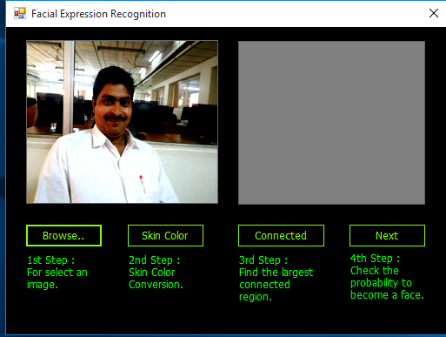

Step1: select an image by clicking browse button

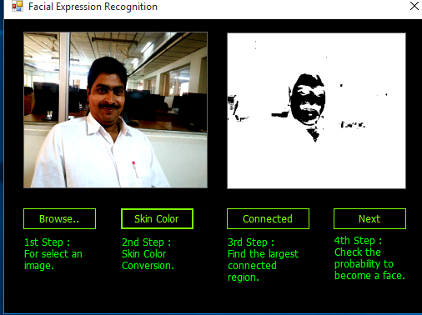

Step2: click on skin color conversion button

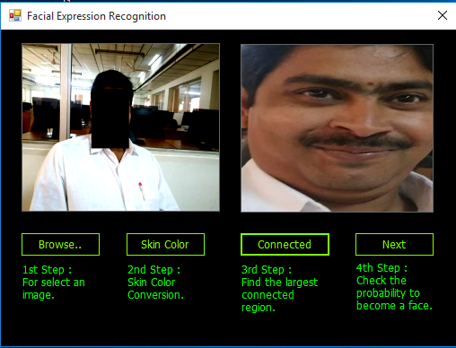

Step3: click connected region button

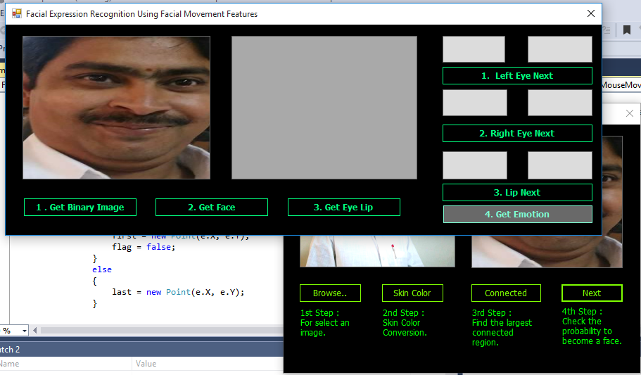

Step4: click on next button that wil check the probability of being a face

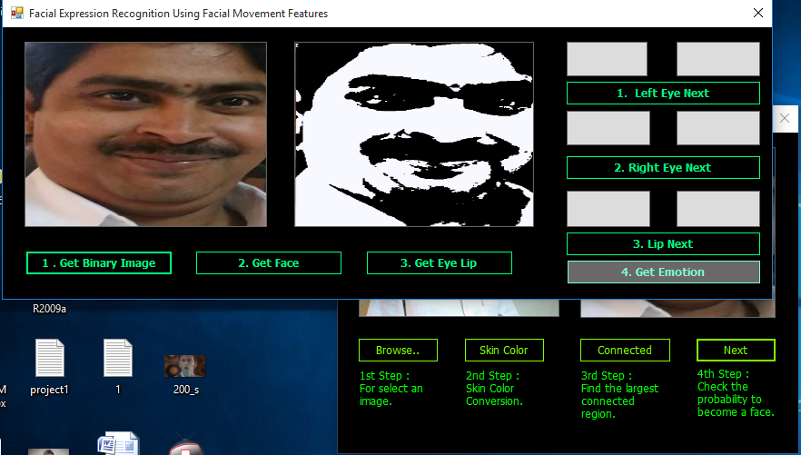

Step5: clickon get binary image button

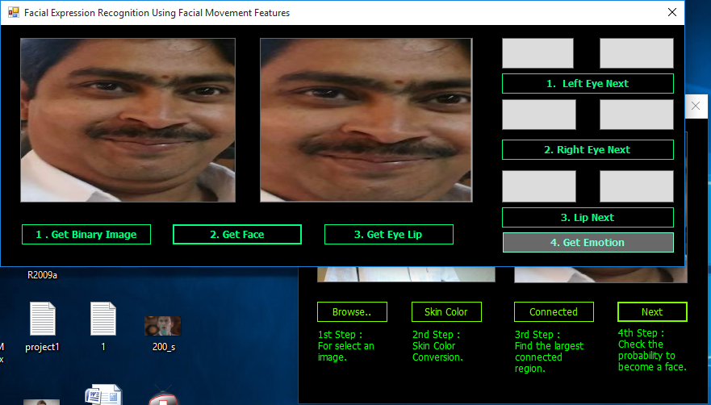

Step6: click on get face button

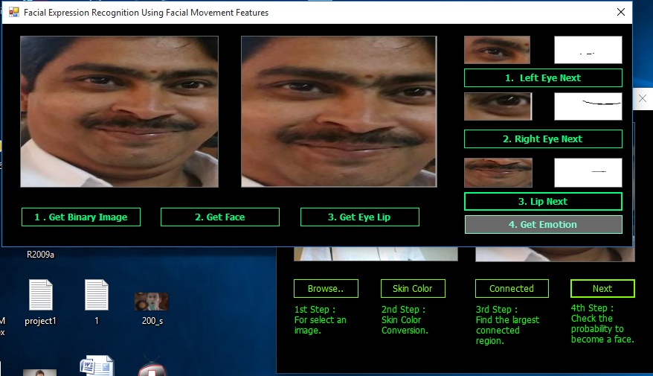

Step7:click on get eye lip button

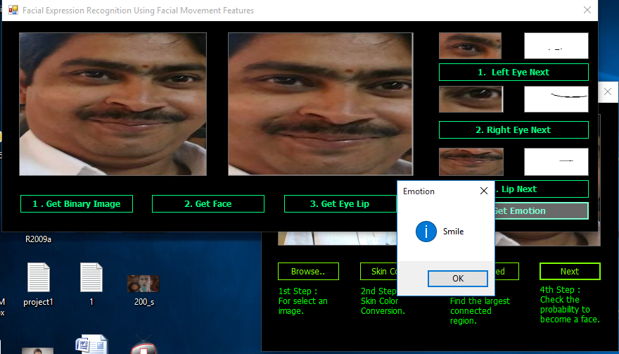

Step8: click on get emotion button

**CHAPTER 6**

**TESTING**

**Testing:**

Testing is the process of analyzing a system or system component to detect the differences between the specified and observed system. Testing needs to be performed under time and budget. The goal of testing is to design tests that defects in the system and is to reveal problems by maximizing the faults.

**Overview of Testing:**

Reliability is a measure of sucess with which of a system conforms to the specification of its behavior. Software reliability is the probabailty that a system will not cause the failure of the system for a specified time under specified conditions. Failure is any processing by the system will lead to a failure. Fault is also called defect or bug. Testing increases the reliability of the system.

The explicit goal of the testing is to demonstrate the faults. Most activities of the development process are constructive during analysis, design and implementation, objects and relationships are identified, refined and mapped onto a computer environment. Testing requires different thinking. One reason is the way we use the word “SUCCESS” during testing it doesn’t detect even one error. Then we call it as a SUCCESSFUL and UNSUCCESSFUL means something undesirable during testing.

**Quality Control Techniques:**

These are many techniques for increasing the reliability of software system. We have three classes of techniques for avoiding and tolerating faults.

* **Fault Avoidance Techniques :**

It tries to prevent the occurrence of errors and failures by finding faults in the system before it is released. It includes

1. **Development methodologies**: Avoid faults by providing techniques that minimize fault introduction in the system models and code.
2. **Configuration management techniques:** Avoid the faults caused by undescribed change in the system interface without notifying all developers of calling component.
3. **Verification:** Attempt to find the faults before any execution of the system . it possible in specific cases such as the verification of a small operating system.
4. **Review:** Review is the manual inspection of parts or allaspects of the system without actually executing the system. There are two types of reviews.

**(a)** **Walk through**: Developer informally presents the API the code and associated documention of the component to the review team. This makes components on the mapping of the analysis and objects design to the code using usecases and scenarios from the analysis phase.

(b) **Inspection:** It is similar to walk through presentation of the unit in this format .

This is done by review team.

* **Fault Detection Techniques**:

1. **Debugging**: Assumes that faults can be found by starting from an unplanned failure.

There are two types of debugging techniques.

1. **Correctness debugging**: The goal is to find any deviation between observed and specified functional requirements
2. **Performance debugging**: This addresses the deviation between observed and specified non functional requirements, such as response time.
3. **Testing**: Testing is a fault detection technique that tries to create failures or error in a planned way.

There are some types of techniques:

1. **Unit testing**: It tries to find faults in participating objects and use case models.

2. **Integrating testing:** It finds the faults when testing the individually testing components together

3. **Structural testing**: Finds differences between the system design model and a subset of integrated subsystems.

* **Fault Tolerance Techniques**:

These techniques assume that a system can be released with faults and that system failures can be dealt with by recovering from them at runtime.

**Testing Concepts**:

The following are the testing concepts:

**Components**:

It is a part of the system that can be isolated for testing.

E.g.- An object, a group of objects or one or more subsystems.

**Fault**:

It is also called a bug or defect, is a design or coding mistake that may cause abnormal component behavior.

**Error:**

It is a manifestation of a fault during the execution of the system.

**Failure:**

It is a deviation between the specification of a component of a component and its behaviorA failure is triggered by one or more errors**.**

**Test case**:

It is a set of inputs and expected results that exercise a component with the purpose of causing failure and detecting faults.

Test cases are classified into black box tests and white box tests, depending on which aspect of the system model is tested.

1. **Black box tests:** focus on the input/output behavior of the component. It does not deal with the internal aspects of the component, nor with the behavior or the structure of the components.
2. **White box tests:** focus on the internal structure of the component. A white box test makes sure that, independently from the particular input/output behavior, every state in the dynamic modes of the object and every interaction among the objects is tested.
3. **Test Stubs**:

It is a partial implementation of components on which the testing components depends.

**Test driver**:

It is a partial implementation of a component that depends on the tested component.

**Correction**:

It is a change to a component. The purpose of correction is to repair a fault.

Same techniques that be used to handle some faults

1. **Problem tracking:** includes the documentation of each failure, erroneous state, and fault detected, its correction, and the revisions of the components involved in the change.
2. **Regression testing:** includes the re-execution of all prior tests after a change. This ensures that functionally which worked before the correction has not been affected. It is important in object oriented methods, which call for an iterative development process.
3. **Rational maintenance:** includes the documentation of the rationale for the change and its relationship with the rationale of the revised component. Rationale maintenance enables developers to avoid introducing new faults by inspecting the assumptions that were used to build the component.

**Testing Activities**:

The technical activities are:

* **Component Inspection**:

Inspection finds faults in an individual component through the manual inspection of its source code. Inspection can be conducted before or after the unit test. The inspection is conducted by a team of developers, including the author of the component, a moderate who facilitates the process, and one or more reviewers who find faults in the component. The first inspection process was Fagan’s inspection method.

The steps in Fagan’s inspection method are as follows

* **Overview**: The auth of the component presents the purpose and scope of the component and the goals of the inspection.
* **Preparation**: The reviewers become familiar with the implementation of the component.
* **Inspection meeting**: A reader paraphrases the sources code of the component, and inspection team raises issues with the component.
* **Rework**: The author revises the component.
* **Follow-up**: The moderator checks the quality of the rework of the rework and determines the component that needs to be re-inspected.
* **Usability Testing**:

Usability testing tests the user understands of the system. Usability testing does not compare the system against a specification.

* **Scenario test**:

During this test, one or more users are presented with a visionary scenario of the system.

* **Prototype test**:

During this type of test, the end users are presented with a piece of software that implements key aspects of the system.

* **Product test**:

This test is similar to the prototype test except that a functional version of the system is used in place of the prototype. It conducted after most of the system is developed.

**3**. **Unit Testing**:

It focuses on the building blocks of the software system i.e., objects and subsystems. Many unit testing techniques are available the most important ones are

* **Equivalence Testing**

It is a block box testing technique that minimizes the no of test cases, to test the behavior associated with an equivalence class we need to test one member of the class.

The steps in this are

1. Identification of the equivalence class
2. Selection of inputs

* **Boundary Testing:**

Boundary testing is a special case of equivalence testing and focuses on the conditions at the boundary of the equivalence classes. It requires the elements to be selected from the edges of the equivalence class.

* **Path Testing**:

It is a white box testing that identifies faults in the implementation of the component. It exercising all possible paths through the code at least once most faults will trigger failures. The identification of paths requires knowledge of the source code and data structures.

* **State-Based Testing**:

It is mainly used in object oriented systems, it focus on the comparing the resulting state of the system with the expected state.

* **Polymorphism testing**:

Polymorphism introduces a new challenge in testing because it enables message to be bound to different methods based on the class of the target.

**4**. **Integration Testing**:

Integration testing detects faults that have not been detected during unit testing by focusing on small group of components in this two or more components are integrated and tested.

This includes the following strategies:

* **Big-Bang testing**

This strategy assumes that all components are first tested individually and then tested together as a single system. The advantage is that no additional test stubs or drivers are needed.

* **Bottom-Up Testing**

This testing strategy first tests each component of the bottom layer individually and then with components of the next layer up.

* **Top-Down Testing**

This strategy unit tests the components of the top layer first, and then integrates the components of the next layer down.

* **Sandwich Testing**

This strategy combines the bottom up and top down strategies.

1. **System Testing**

It ensures that the computer system compiles with the functional and non functional requirements of the system.

There are several system testing activities are

* **Functional Testing**:

Test of functional requirements.

* **Performance Testing**:

Test of non functional requirements i.e.,

1. Stress Testing
2. Volume Testing
3. Security Testing
4. Timing Testing
5. Recovery Testing

* **Pilot Testing:**

Test common of functionality among a selected group of end users in the target environment. These are also called as field test.

* **Acceptance Testing**:

Usability, functional, and performance test performed by customer in the development environment against acceptance criteria.

The three ways to perform acceptance testing are

1. Benchmark Testing
2. Computer Testing
3. Shadow Testing

* **Installation Testing:**

Usability, functional and performance test performed by customer in the development environment against acceptance criteria. If the system is only installed at a small selected set of customers it is called a beta test.

**Managing Testing**:

The management of testing includes

1. **Planning Testing**:

Developers can reduce the cost of testing and the elapsed time necessary for its completion through care full planning.

1. **Documentation Testing:**

Testing activities are documented in four types of documents

**Test plan**:

The test plan focuses on the managerial aspects of testing.

**Test Case Specification**:

Each test is documented by a test case specification.

**Test Incident Report:**

Each execution of each test is documented by a test incident report.

**Test Summary Report:**

This document lists all the failures that were discovered during the test and that need to be investigated.

1. **Assigning Responsibilities:**

Testing requires developers to find faults in components.

Testing team is provided with the system models, source code and system developing and executing test cases.

Test document is used for communicating among subsystem teams.

1. **Regression Testing**:

A system that fails after the modification of a component is said to regress. Hence integration tests that are written on the system to produce such failures are called regression test.

As regression testing can become time consuming different techniques have been develop for selecting specific regression test. Such techniques includes:

* **Retest dependent component**
* **Retest risky use cases**
* **Retest frequent use cases.**

1. **Automating testing:**

The repeatability of test execution can be achieved with automation. Although all aspects of testing can be automated, the main focus of test automatation has been on execution. The benefit of automating test execution is that tests are repeatable. Once a font is corrected as a result of failure the test that uncovered the failure can be repeated.

**Test cases:**

**Smile:**



Fig 6.1 smile testcase

**Sad:**

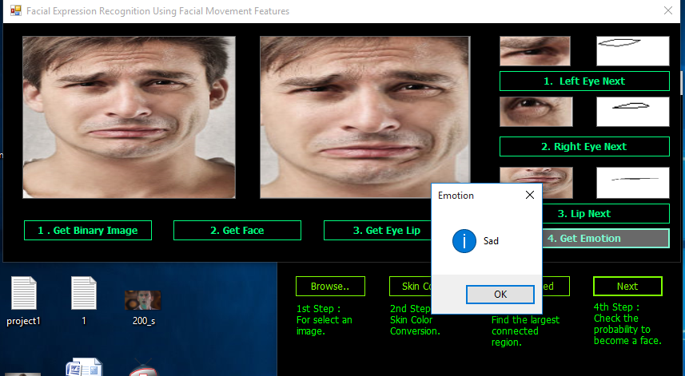

Fig 6.2 sad testcase

**Surprise:**

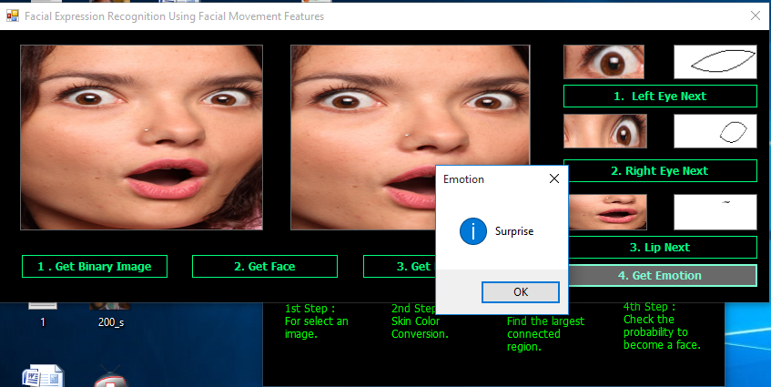

Fig 6.3 surprise testcase

**Neutral:**

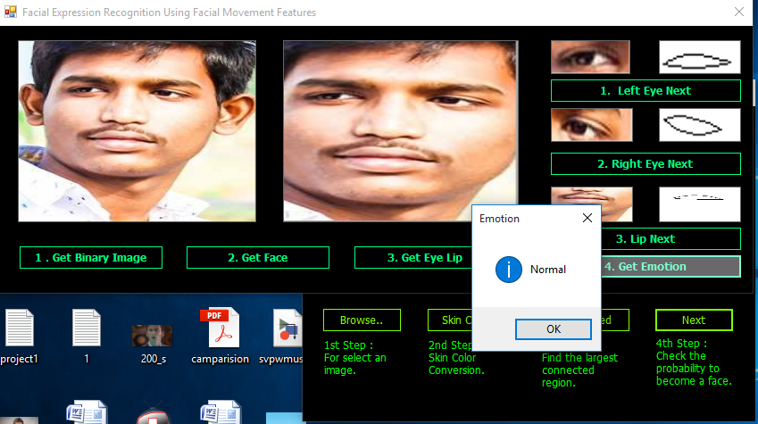

Fig 6.4 neutral testcase

**Detecting non human faces:**

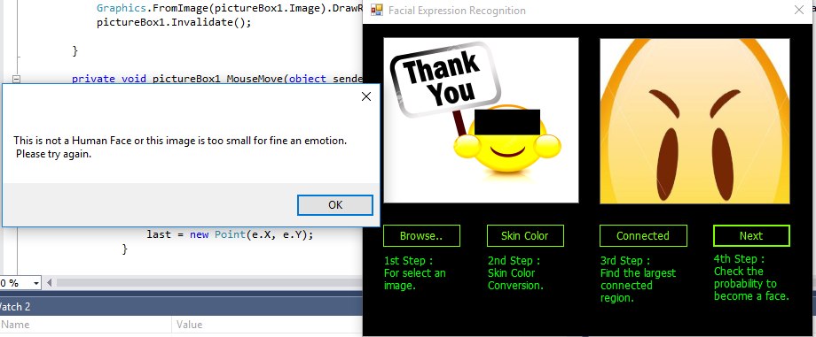

Fig 6.5 detecting non human faces

**CHAPTER 7**

**RESULT ANALYSIS**

In this paper, we have presented and implemented a simple approach for recognition of the facial expression analysis. The algorithm is performed two major steps: one is a detection of facial region with skin color segmentation and calculation of feature-map for extracting two interest regions focused on eye and mouth. And the other is a verification of the facial emotion of characteristic features with the Bezier curve and the Hausdorff distance. Experimental results shows average successful ratio of 78.8% to recognize the facial expression, and this indicates the good performance and enough to applicable to mobile devices.

|  |  |  |
| --- | --- | --- |
| Expression | Correct/miss | Success ratio |
| Smile | 67/12 | 84.8 |
| Sad | 22//8 | 73.3 |
| Surprise | 45/16 | 73.8 |
| Ambigious | 22/8 | 73.3 |
| Neutral | 63/17 | 78.8 |
| Total | 219/62 | 79.0 |

**CHAPTER 8**

**CONCLUSION AND FUTURE SCOPE**

**8.1 Conclusion**

This project proposes a new approach for recognizing the category of facial expression . We have constructed the expression models by using average Bzier curves from several subjects. In this project, four different facial expressions of more than 20 persons pictures have been analyzed. In this project, 3rd order Biezer curve has been used to identify the face outlines and expressions. The adoption of the cubic Biezer curves means only four control points are sufficient to represent a curve. Although this method has been implemented for a few persons, but the experimental results nevertheless demonstrate that our system is reliable if the images represent a distinct view of the faces and are low resolution images. There is a lot of scope for the project to explore, for e.g. by improving the Eye-Lip detection procedure, and trying out the project for images taken at different angles and higher resolutions

**8.2 Future Scope**

High correct recognition rate (CRR), significant performance improvements in our system. Promising results are obtained under face registration errors, fast processing time. System is fully automatic and has the capability to work with video feeds as well as images. It is able to recognize spontaneous expressions. Our system can be used in Digital Cameras where in the image is captured only when the person smiles, or if the person doesnt blink his eyes. In security systems which can identify a person, in any form of expression he presents himself. Rooms in homes can set the lights, television to a persons taste when they enter the room. Doctors can use the system to understand the intensity of pain or illness of a deaf patient.

**REFERENCES**

**Facial expression recognition based on Local Binary Patterns:**

**[Liao, s.., Fan, W., Chung, C.S., & Yeung]**

# Facial Expression Recognition Based on Fusion of Multiple Gabor Features

# [Liu, W., & Wrang]

# Recognition of facial expressions using Gabor wavelets and learning vector quantization [Bashyal & Venayagamoorthy]

# Performance Comparisons Of Facial Expression Recognition In Jaffe Database [Shih, F. Y., Chung]

# Facial Expression Recognition in JAFFE Dataset Based on Gaussian Process Classification

# A Literature review on Facial Expression Recognition Techniques

# [Ms.Aswathy.R]

# Development of a Facial Emotion Recognition Method Based on Combining AAM with DBN

# [Kwang-Eun Ko]

# Facial expression recognition using DCT features and neural network based decision tree

# [Arun Bhadu]